Adaboost(jupyter)

[1] this link to explain Bootstrapping, Bagging,& Boosting :

<https://medium.com/@curryrowan/the-three-bs-bootstrapping-bagging-boosting-43df4b372a6a>

[2] Download Code and DataSet from kaggle:

<https://www.kaggle.com/code/funxexcel/titanic-basic-solution-using-adaboost/notebook>

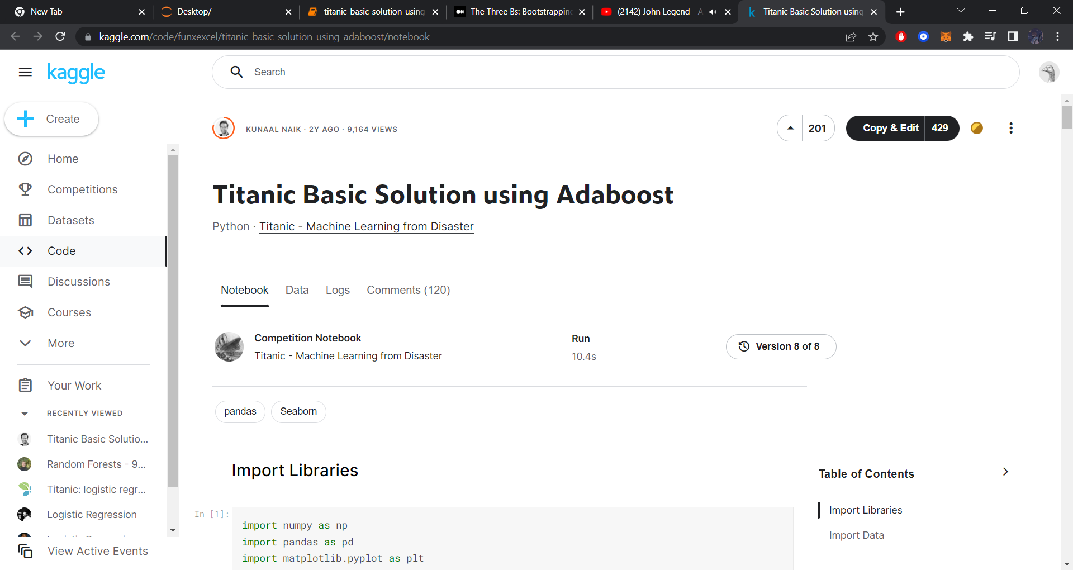

[3] DATASET: The Dataset used is Titanic passengers survivers dataset on Kaggle.

[4] Delete these line of code [import os] and [print(os.listdir("../input"))] , train = pd.read_csv("../input/train.csv")

[5] Change this line of code [train = pd.read_csv("../input/train.csv")] to [train = pd.read_csv("train.csv")] and [test = pd.read_csv("../input/test.csv")] to test = pd.read_csv("test.csv") as follow..

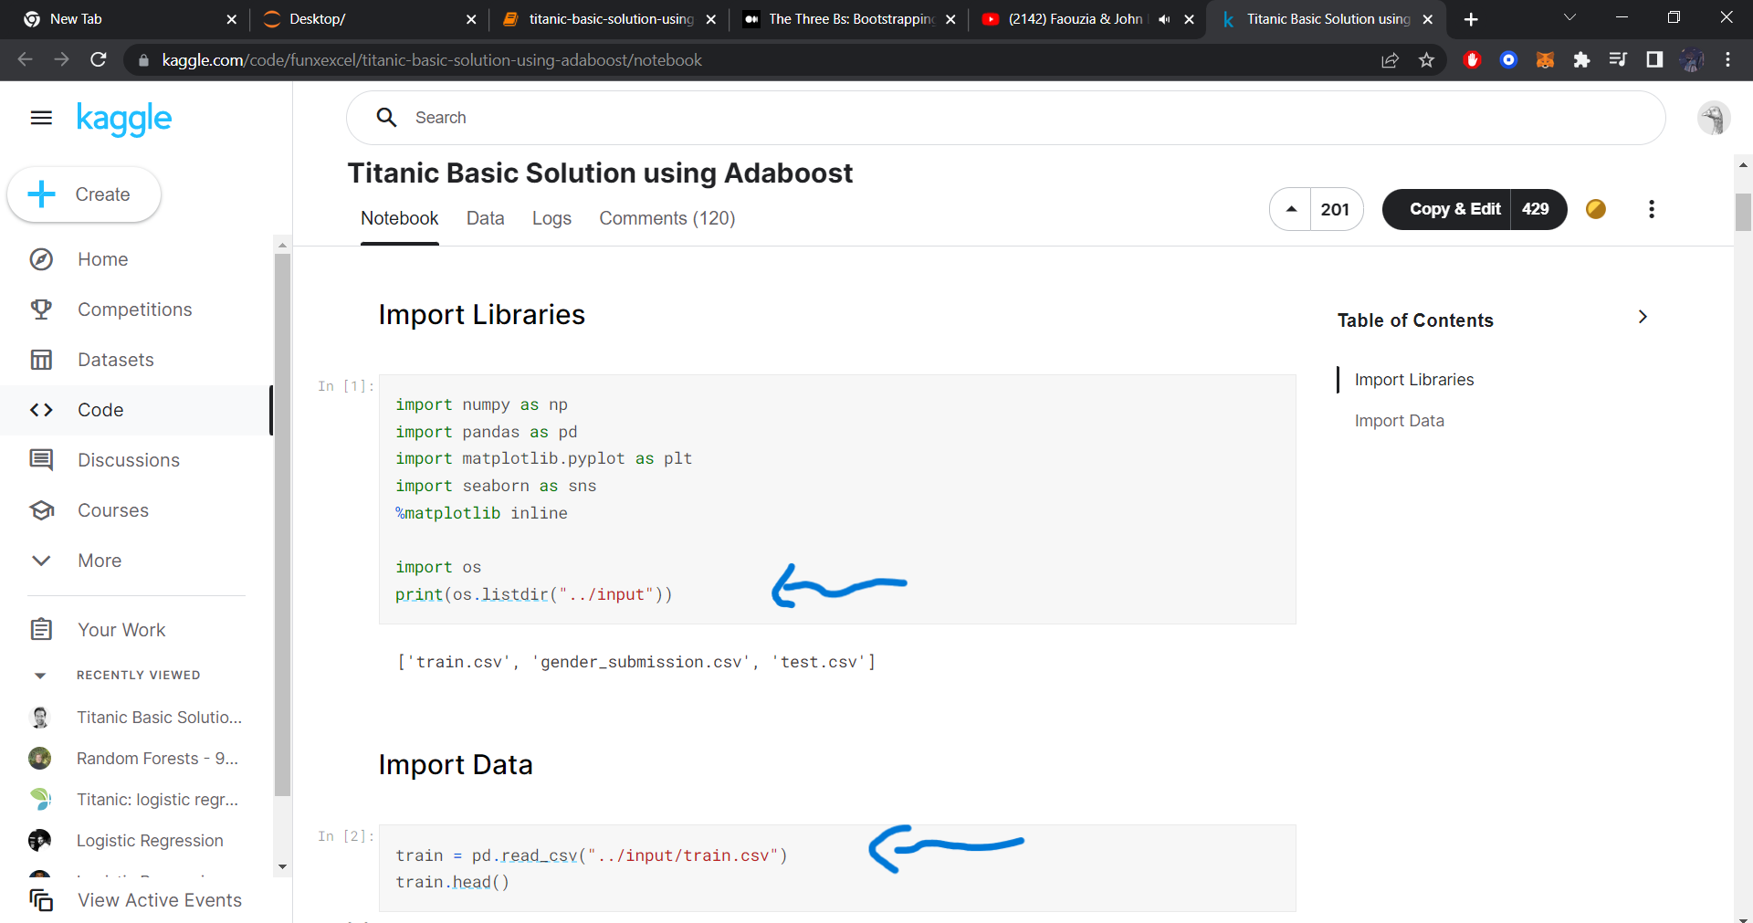

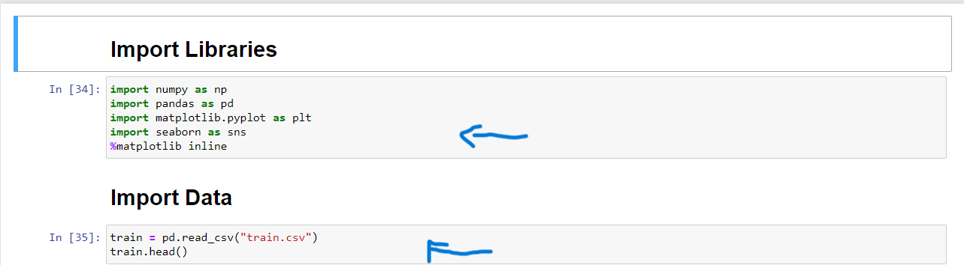

[6]Run the code!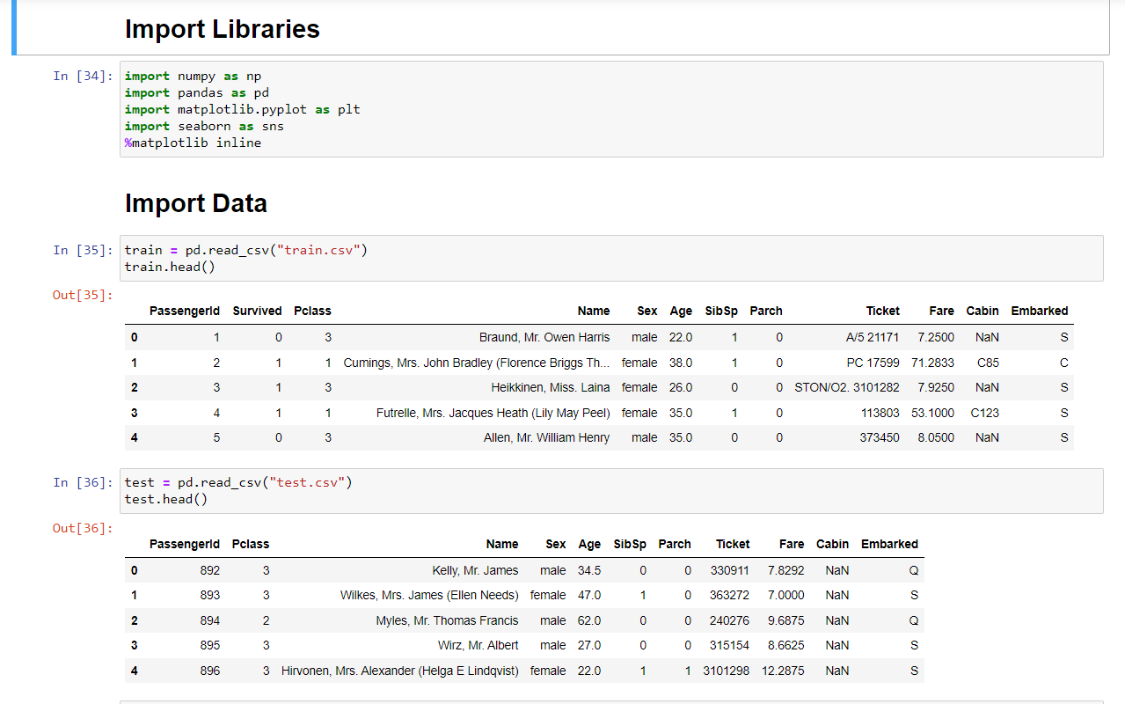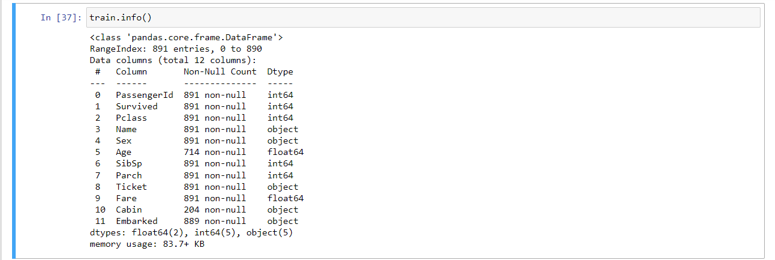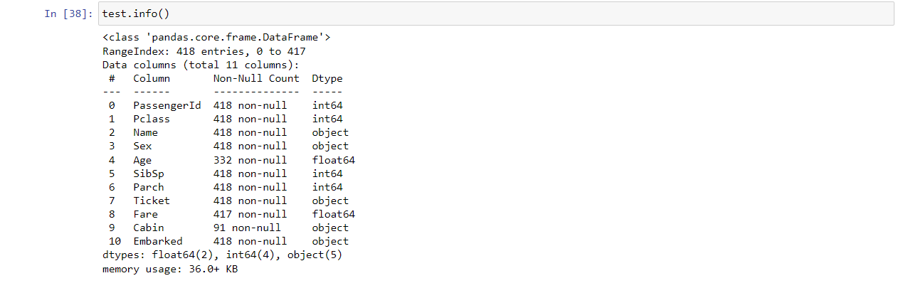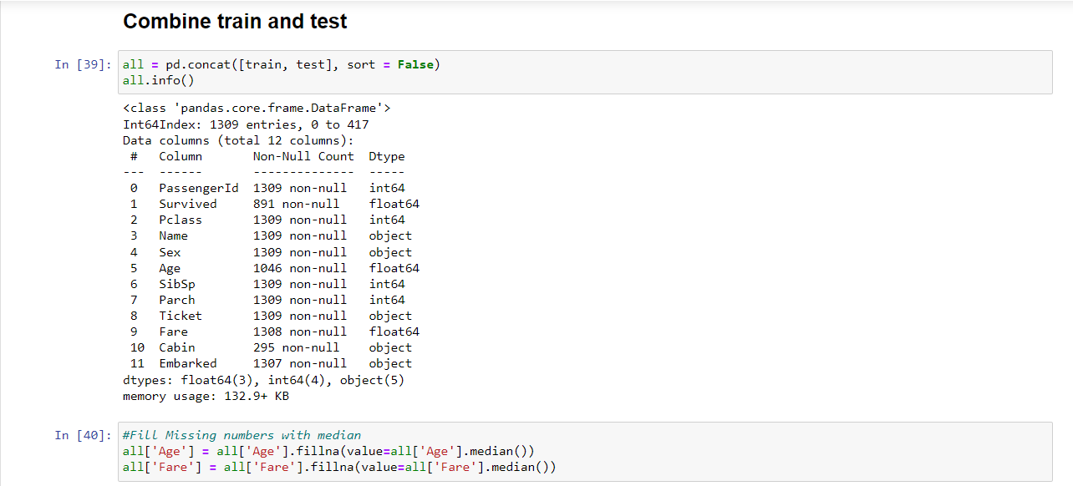

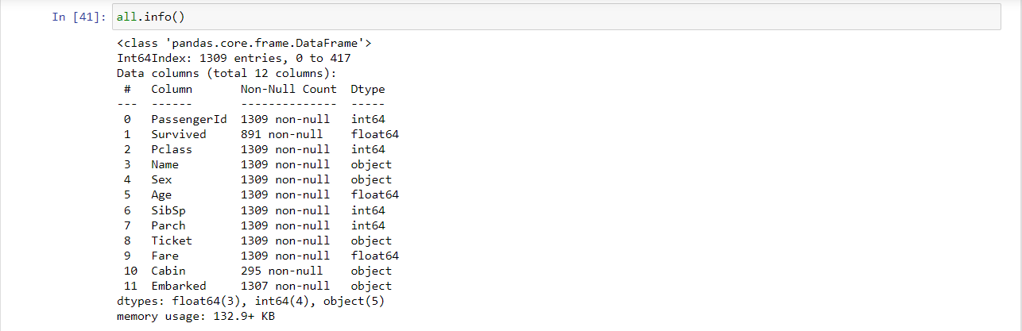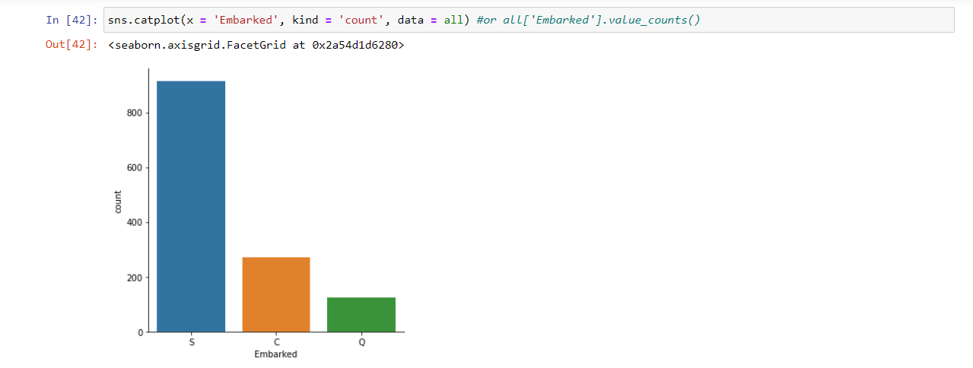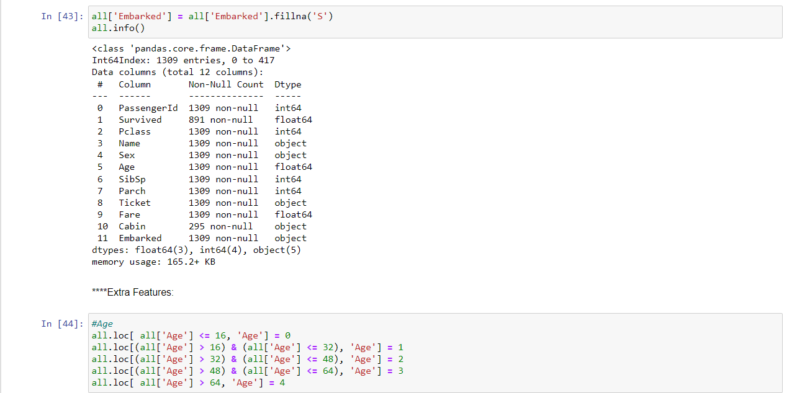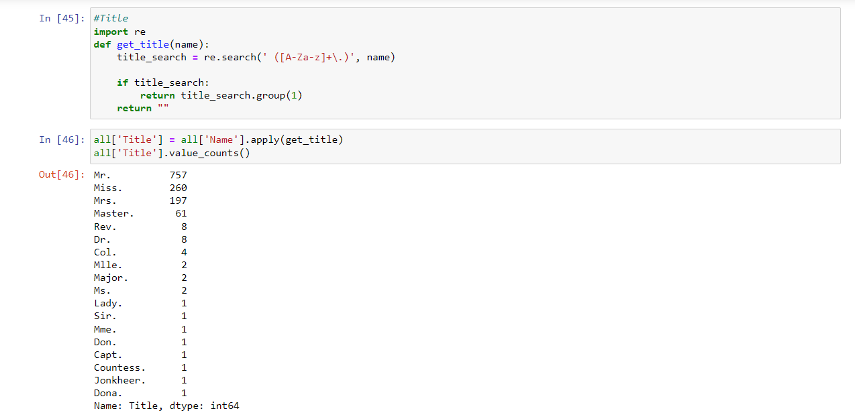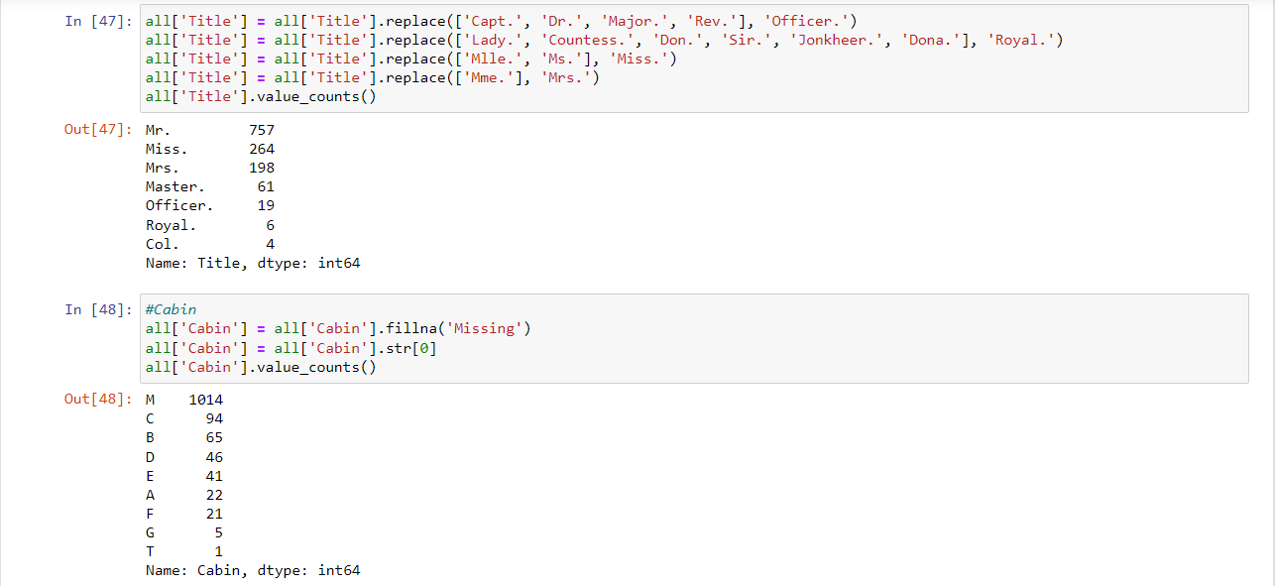

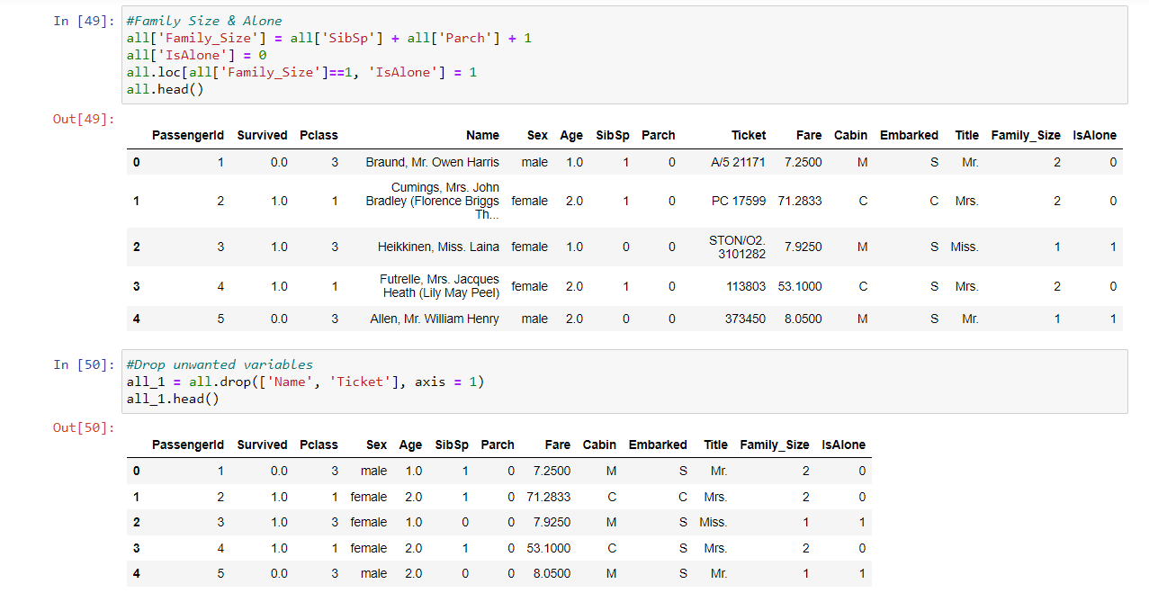

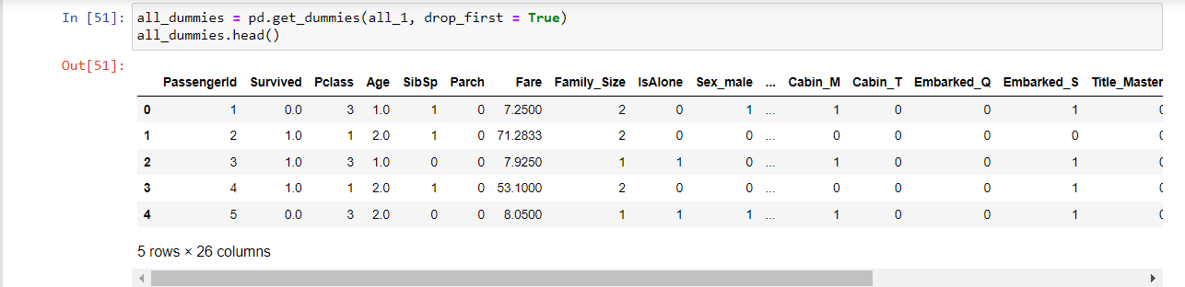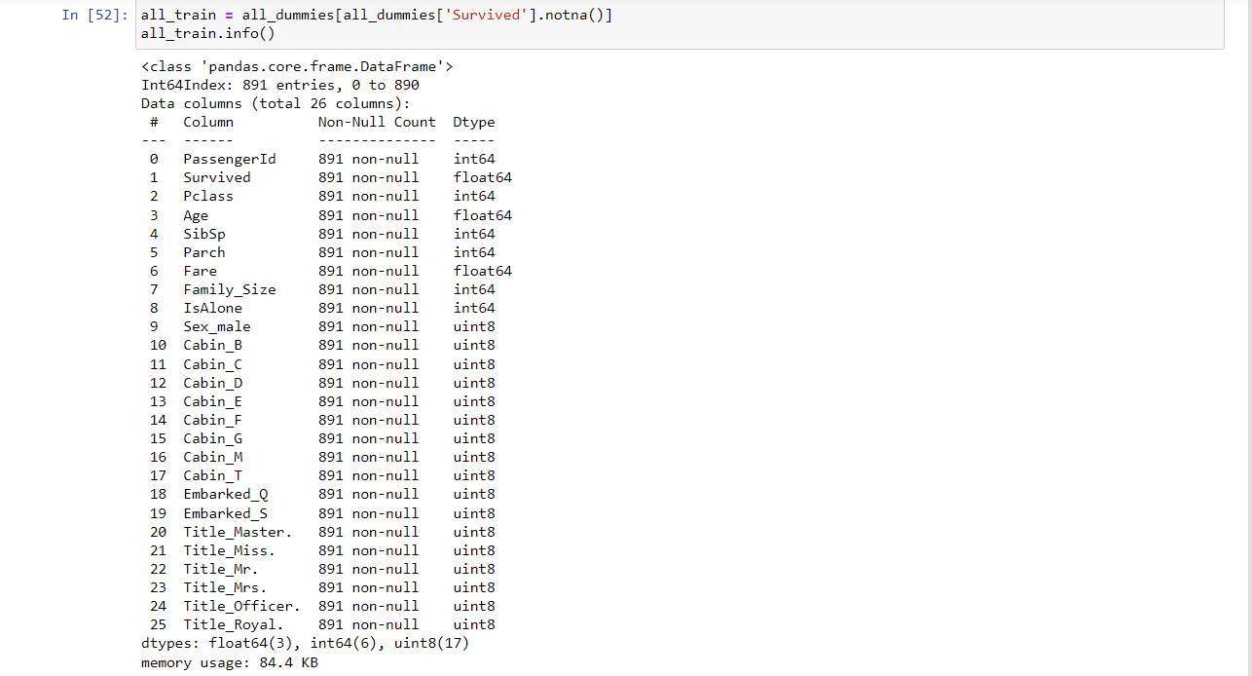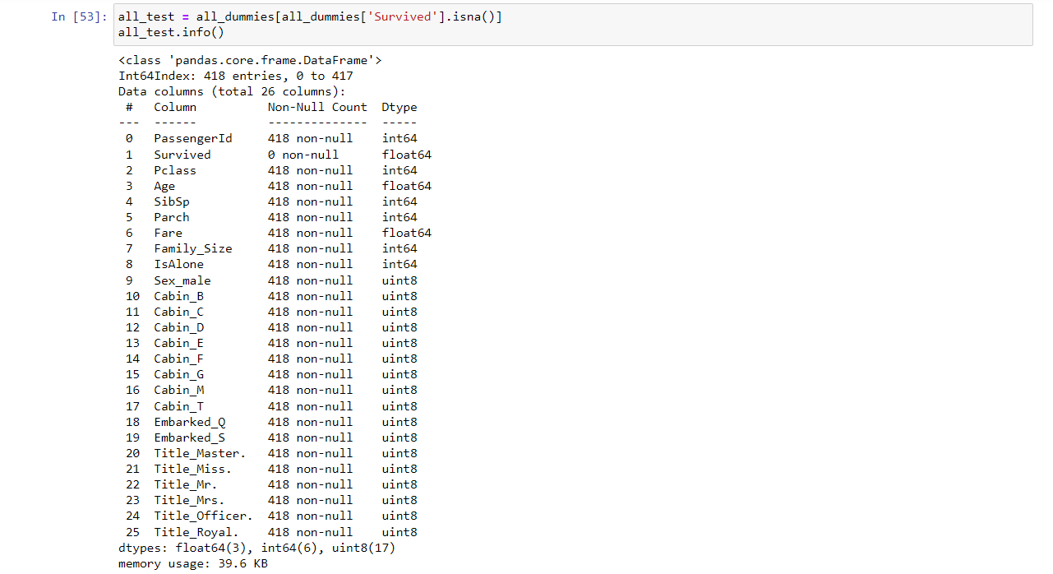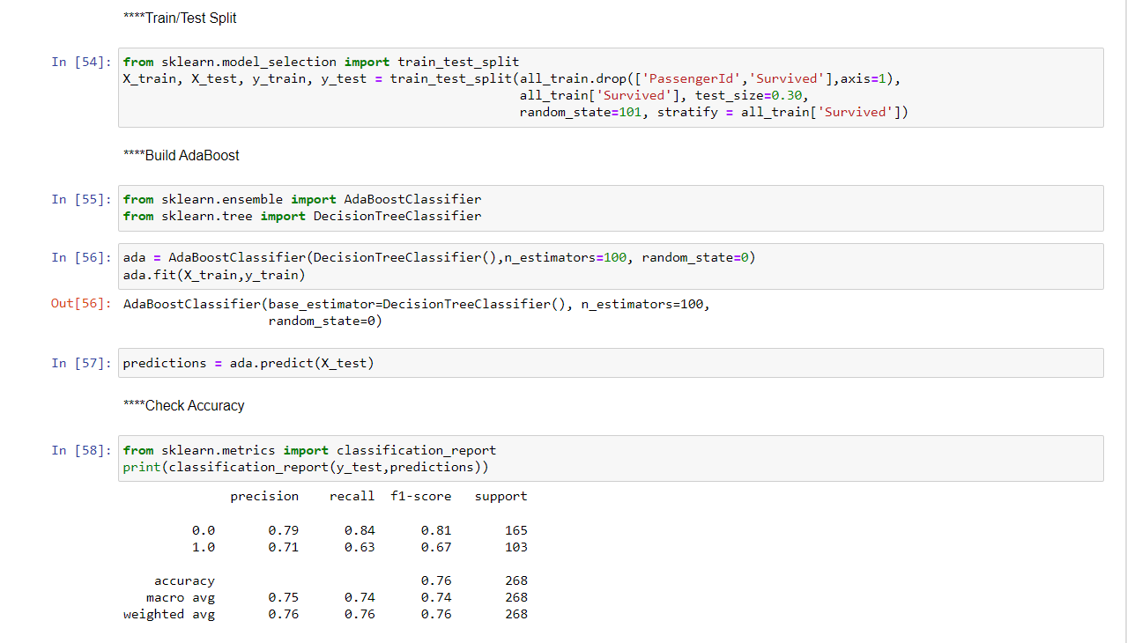

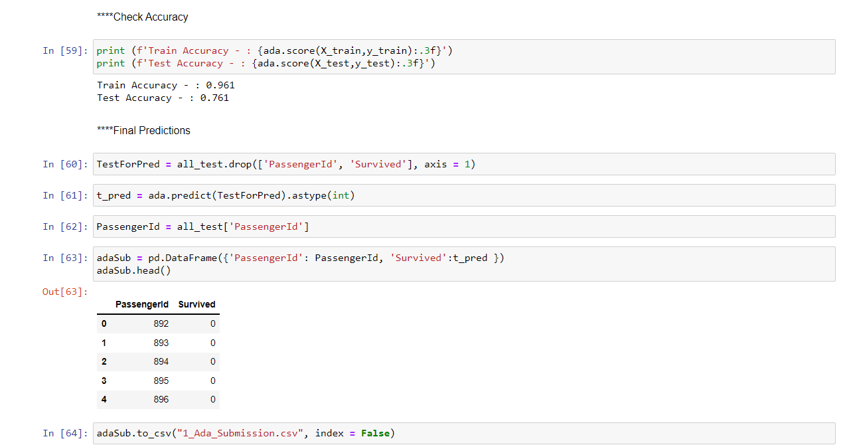

[7] Accuracy for train = 0.961.

Accuarcy for test = 0.761.

### Name : Ramah hashem madi

### ID no. : 31909303044